- Create ENI & Attach ENI vào instance
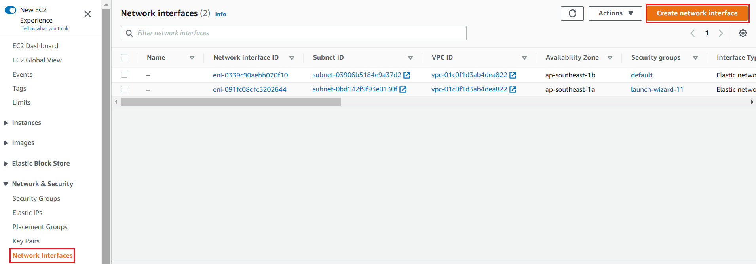  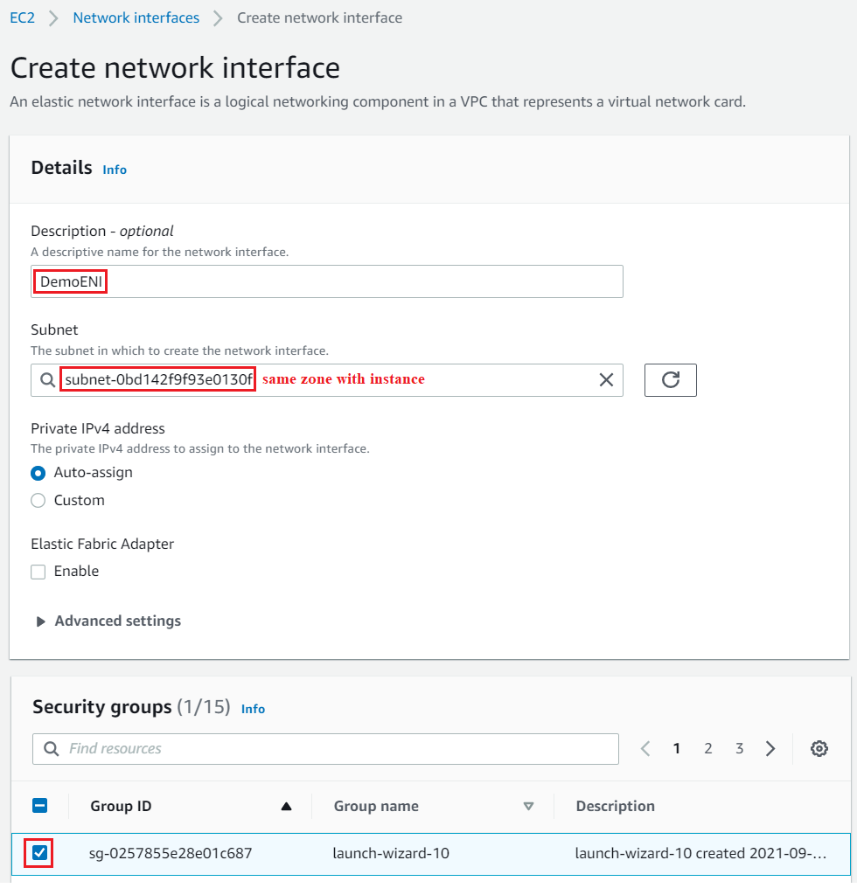  Create ENI | 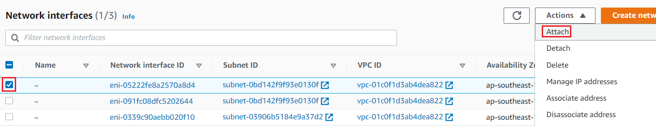  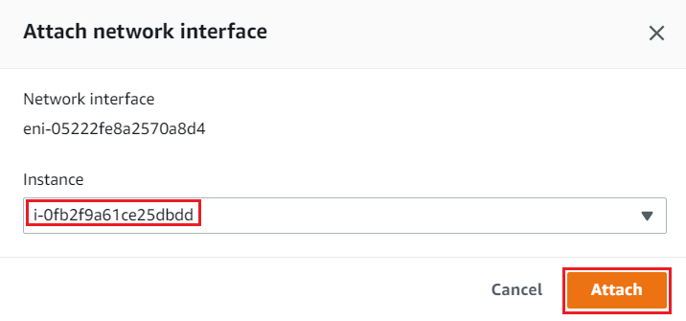  Attach ENI vào instance  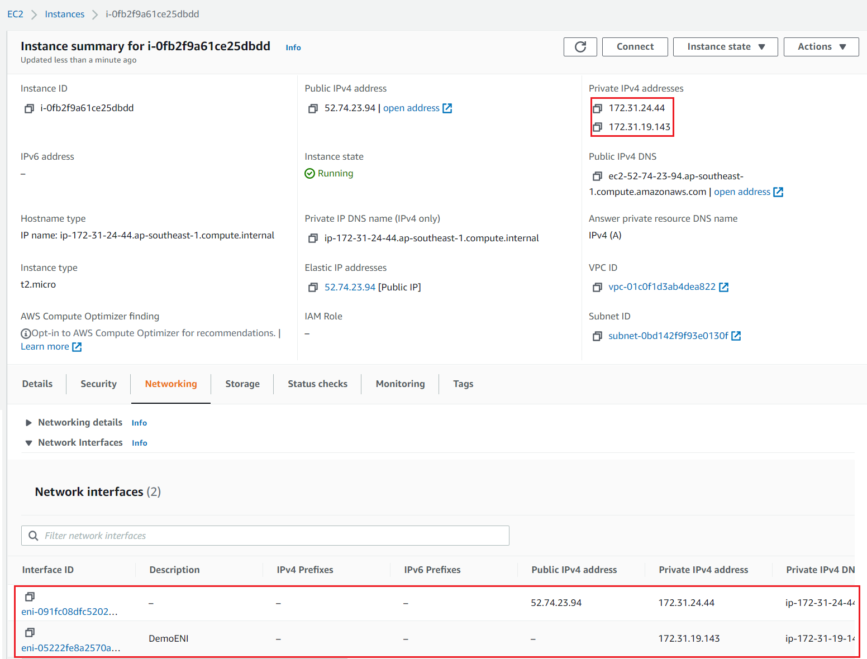  Result

- Elastic IP
  - Restart instance thì sẽ thay đổi public IP của 1 instance
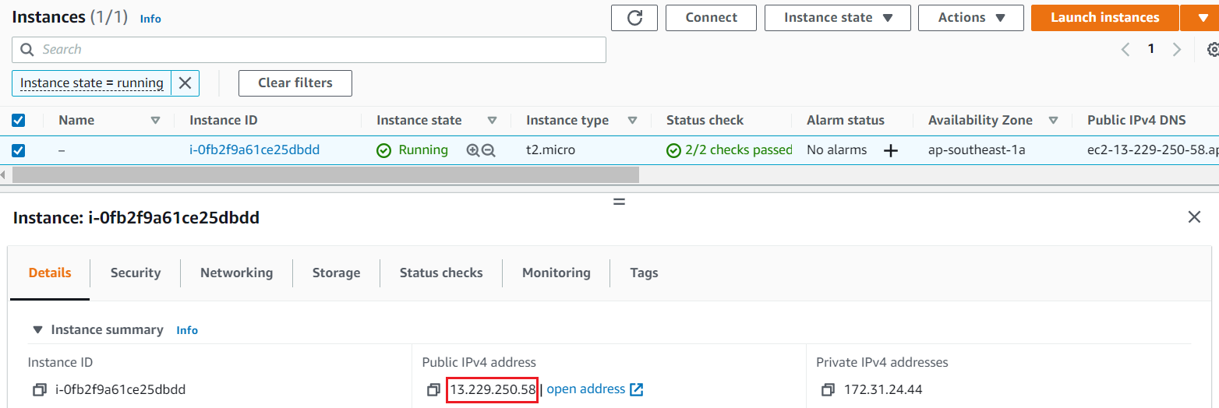 | 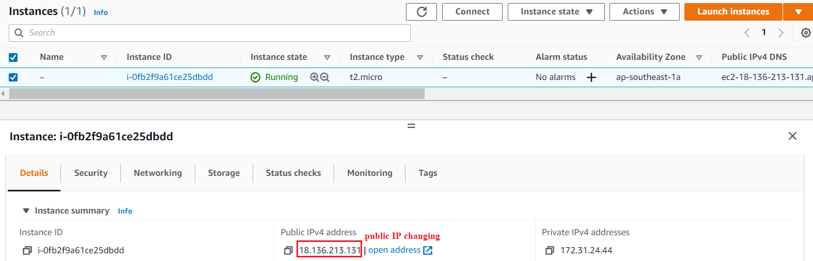  Stop Start again instance
  - Attach Elastic IP vào instance
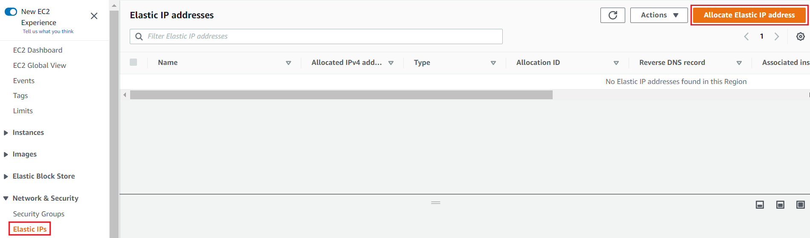  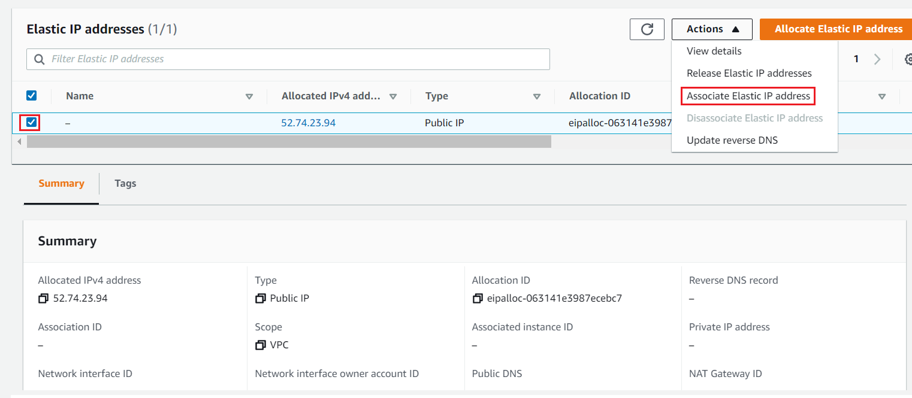 | 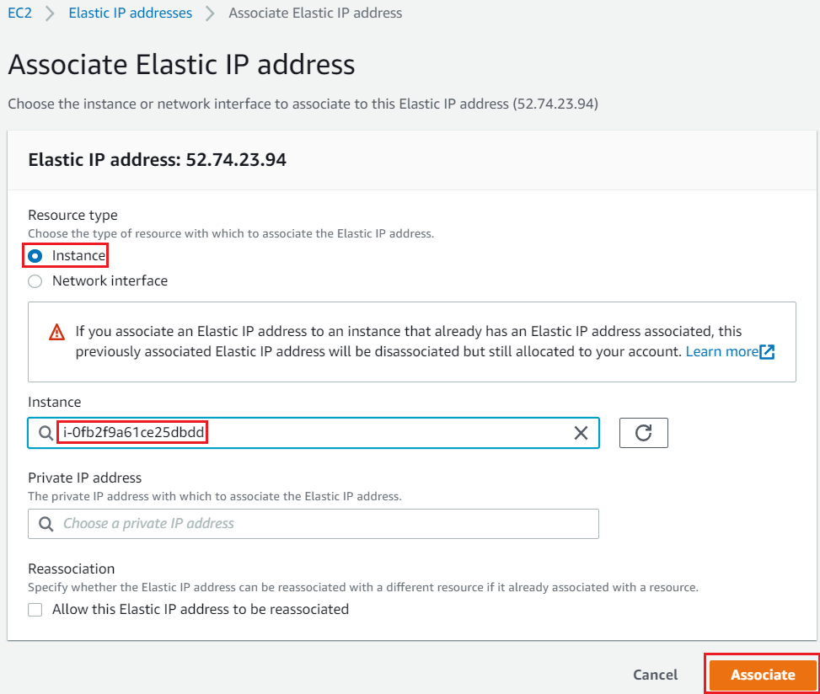  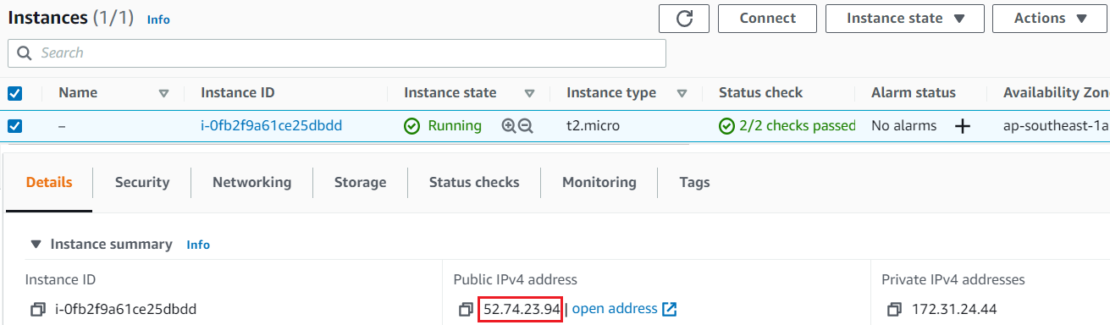
https://docs.aws.amazon.com/AWSEC2/latest/UserGuide/elastic-ip-addresses-eip.html#working-with-eips

- Placement group
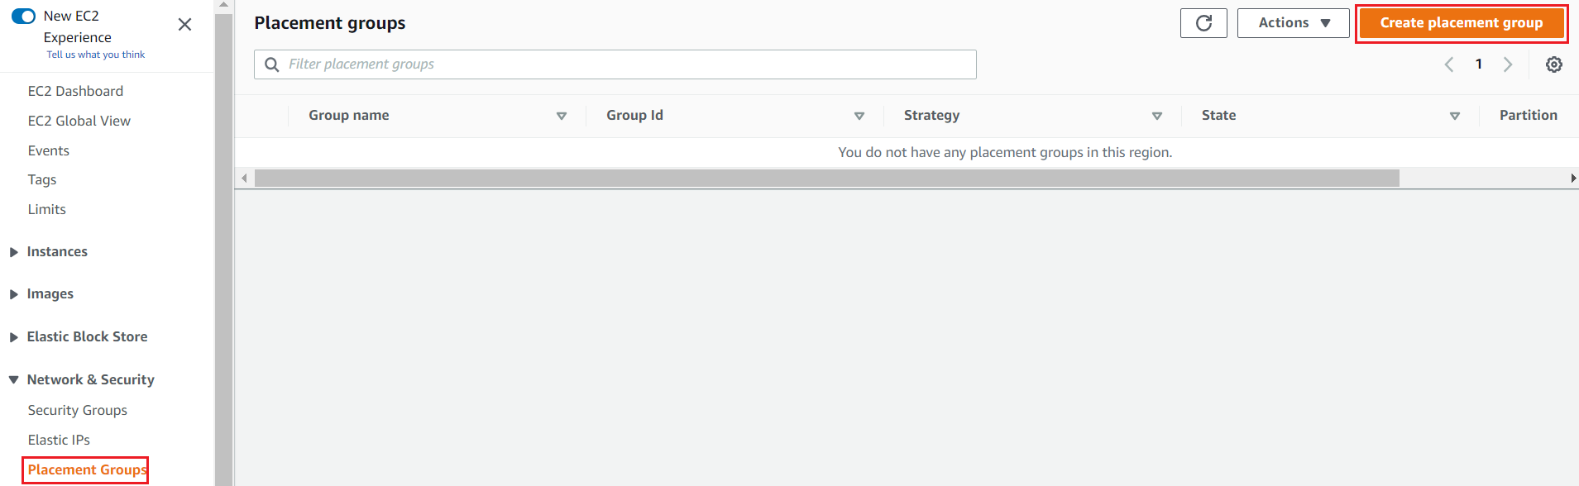  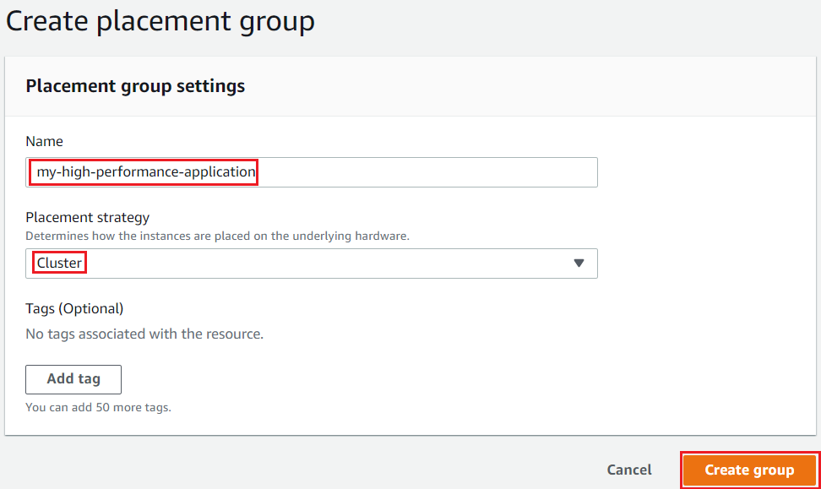  Create Placement group | 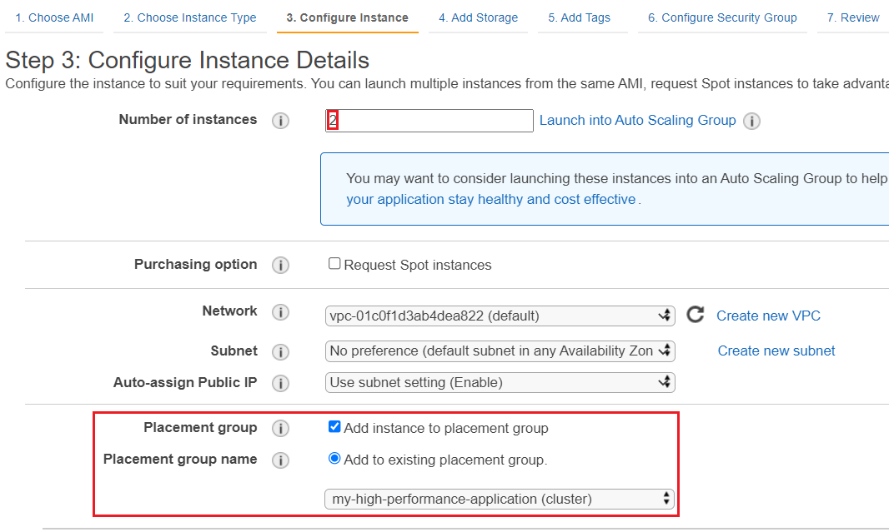  Init new instances  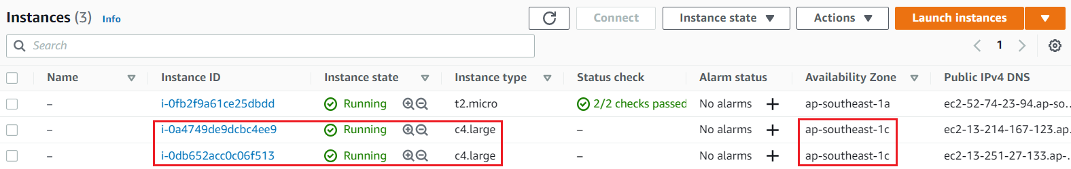  Result

- Other
  - Ip
    - Xem IP
https://docs.aws.amazon.com/AWSEC2/latest/UserGuide/using-instance-addressing.html#working-with-ip-addresses
    - Gán thêm IP
https://docs.aws.amazon.com/AWSEC2/latest/UserGuide/MultipleIP.html

  - Network interface
https://docs.aws.amazon.com/AWSEC2/latest/UserGuide/using-eni.html#working-with-enis

  - Enhanced networking
https://docs.aws.amazon.com/AWSEC2/latest/UserGuide/enhanced-networking.html#enabling_enhanced_networking

  - Placement group
https://docs.aws.amazon.com/AWSEC2/latest/UserGuide/placement-groups.html#create-placement-group

- Reference

